--DDL Commands.

SQL> --add new column, delete existing columns, renames column names, modify column datatype.

SQL> select * from cust;

no rows selected

SQL> insert into cust values('&name', '&city');

Enter value for name: krish

Enter value for city: delhi

old 1: insert into cust values('&name', '&city')

new 1: insert into cust values('krish', 'delhi')

1 row created.

SQL> /

Enter value for name: avinash

Enter value for city: chennai

old 1: insert into cust values('&name', '&city')

new 1: insert into cust values('avinash', 'chennai')

1 row created.

SQL> /

Enter value for name: vijay

Enter value for city: chennai

old 1: insert into cust values('&name', '&city')

new 1: insert into cust values('vijay', 'chennai')

1 row created.

SQL> select * from cust;

CNAME CITY

---------- ----------

krish delhi

avinash chennai

vijay chennai

SQL> --modify cust table to maintain mobile numbers and genders

SQL> alter table cust

2 add

3 (

4 mobno number(10),

5 gender varchar2(10)

6 );

Table altered.

SQL> select * from cust;

CNAME CITY MOBNO GENDER

---------- ---------- ---------- ----------

krish delhi

avinash chennai

vijay chennai

SQL> alter table cust

2 ;

*

ERROR at line 2:

ORA-02210: no options specified for ALTER TABLE

SQL> update cust set gender='male';

3 rows updated.

SQL> select * from cust;

CNAME CITY MOBNO GENDER

---------- ---------- ---------- ----------

krish delhi male

avinash chennai male

vijay chennai male

SQL>

SQL>

SQL> --delete existed columns

SQL> alter table cust

2 drop column mobno;

Table altered.

SQL> select * from cust;

CNAME CITY GENDER

---------- ---------- ----------

krish delhi male

avinash chennai male

vijay chennai male

SQL> --decrease size of cname

SQL> --using modify command;

SQL> alter table cust

2 modify cname varchar2(7);

Table altered.

SQL> desc cust;

Name Null? Type

----------------------------------------- -------- ----------------------------

CNAME VARCHAR2(7)

CITY VARCHAR2(10)

GENDER VARCHAR2(10)

SQL> alter table cust

2 modify cname varchar2(6);

modify cname varchar2(6)

*

ERROR at line 2:

ORA-01441: cannot decrease column length because some value is too big

SQL> --if already data exists, then we cant reduse the size less than the existed data size according to above example.

SQL> alter table cust

2 add (mobno number(10),

3 );

)

*

ERROR at line 3:

ORA-00904: : invalid identifier

SQL> ed

Wrote file afiedt.buf

1 alter table cust

2 add (

3 mobno number(10),

4* )

SQL> /

)

*

ERROR at line 4:

ORA-00904: : invalid identifier

SQL> ed

Wrote file afiedt.buf

1 alter table cust

2 add (

3 mobno number(10)

4* )

SQL> /

Table altered.

SQL> --changing the datatype

SQL> sdesc cust

SP2-0042: unknown command "sdesc cust" - rest of line ignored.

SQL> desc cust

Name Null? Type

----------------------------------------- -------- ----------------------------

CNAME VARCHAR2(7)

CITY VARCHAR2(10)

GENDER VARCHAR2(10)

MOBNO NUMBER(10)

SQL> alter table cust

2 modify (

3 mobno varchar2(10)

4 );

Table altered.

SQL> desc cust

Name Null? Type

----------------------------------------- -------- ----------------------------

CNAME VARCHAR2(7)

CITY VARCHAR2(10)

GENDER VARCHAR2(10)

MOBNO VARCHAR2(10)

SQL> alter table cust

2 modify (

3 city number(10)

4 );

city number(10)

*

ERROR at line 3:

ORA-01439: column to be modified must be empty to change datatype

SQL> -- from the above example , we can change the datattype of the column if there iss no data exists in that column.

SQL> --if there exists any data already, we can not change the datatype.

SQL> alter table cust

2 modify (

3 mobno number(14)

4 );

Table altered.

SQL> select * from cust;

CNAME CITY GENDER MOBNO

------- ---------- ---------- ----------

krish delhi male

avinash chennai male

vijay chennai male

SQL> update cust

2 set mobno=+919876543210 where cname='krish';

1 row updated.

SQL> --rename old column name to new column name

SQL> select * from cust;

CNAME CITY GENDER MOBNO

------- ---------- ---------- ----------

krish delhi male 9.1988E+11

avinash chennai male

vijay chennai male

SQL> alter table cust

2 rename culumn cname to customer_name;

rename culumn cname to customer_name

*

ERROR at line 2:

ORA-14155: missing PARTITION or SUBPARTITION keyword

SQL> alter table cust

2 rename culumn cname to customername;

rename culumn cname to customername

*

ERROR at line 2:

ORA-14155: missing PARTITION or SUBPARTITION keyword

SQL> alter table cust

2 rename column cname to customername;

Table altered.

SQL> alter table cust

2 rename to customer_details;

Table altered.

SQL> select * from customer_details;

CUSTOME CITY GENDER MOBNO

------- ---------- ---------- ----------

krish delhi male 9.1988E+11

avinash chennai male

vijay chennai male

SQL> select * from cust;

select * from cust

*

ERROR at line 1:

ORA-00942: table or view does not exist

SQL> alter table cust

2 rename to cust;

alter table cust

*

ERROR at line 1:

ORA-00942: table or view does not exist

SQL> alter table customer_details

2 rename to cust;

Table altered.

SQL> select * from cust;

CUSTOME CITY GENDER MOBNO

------- ---------- ---------- ----------

krish delhi male 9.1988E+11

avinash chennai male

vijay chennai male

SQL> -- we can delete any db object using drop command.

SQL> -- we can rename any db object by using rename command.

SQL> --- truncate deletes the table data completely.

SQL>

SQL> -- rollback also can not get back the data if we use truncate

SQL> create table ss as select * from cust;

create table ss as select * from cust

*

ERROR at line 1:

ORA-00955: name is already used by an existing object

SQL> truncate table cust;

Table truncated.

SQL> select * from cust;

no rows selected

SQL> desc cust;

Name Null? Type

----------------------------------------- -------- ----------------------------

CUSTOMERNAME VARCHAR2(7)

CITY VARCHAR2(10)

GENDER VARCHAR2(10)

MOBNO NUMBER(14)

SQL> -- we can see the structure only

SQL> -- but for drop command we casn not find structure also.

SQL> -- dont use the truncate command unnecessarily.

SQL> -- in 11g, 12c enterprice edition only(not express edition), if we delete any file or drop table then we can find it in recycle bin.

SQL> --it will be available for any number of days.

SQL> -- we can restore the deleted table by using the following table.

SQL> --we can delete the table perminantly from recycle bin also by using following command.

SQL> --purge table table-name;

SQL> spool off

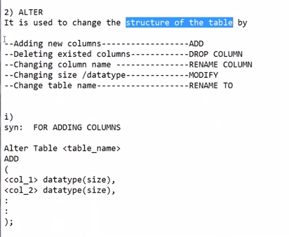

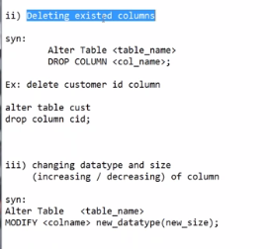

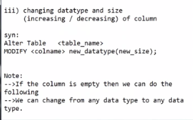

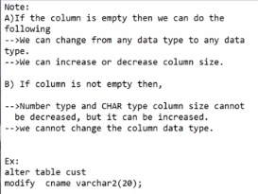

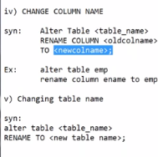

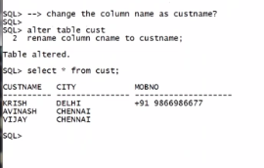

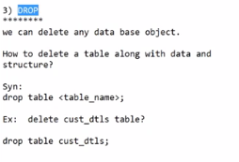

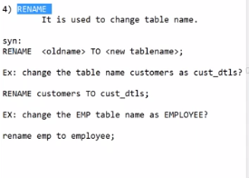

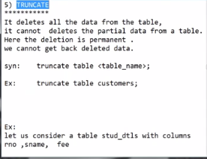

-- -- in 11g, 12c enterprice edition only(not express edition), if we delete any file or drop table then we can find it in recycle bin.

